

Click here to enter text.

Operating Budget

**For the Fiscal Years**

**2022/23, 2023/24 and 2024/25**

TABLE OF CONTENTS

1 Key Considerations 1

2 Mission 1

3 Enrolment Trends 1

4 Objectives 2022/23 – 2024/25 1

4.1 Overall Objectives 1

4.1.1 Enrolments: 1

4.1.2 Student Experience and Skills: 1

4.1.3 Economic and Societal Impact: 2

4.2 Internal Benchmarks 2

4.3 Significant new initiatives 2

4.3.1 Name of new initiative #1 2

4.3.2 Name of new initiative #2 2

4.4 Alignment with Strategic Mandate Agreement and McMaster Strategy 2

4.5 Non-priority activities or programs reduced/ eliminated 3

5 External Benchmarks 3

6 the Budget PLAN 3

6.1 Revenue 4

6.1.1 Operating allocation 4

6.1.2 All other revenue 4

6.2 Staffing 4

6.2.1 Academic positions 4

6.2.2 Staff Positions 5

6.3 Other expenses 5

6.4 Significant cost pressures 6

6.4.1 Name of cost pressure #1 6

6.4.2 Name of cost pressure #2 6

6.5 Summary of items in Budget 6

6.6 Plans for use of appropriations 6

6.7 Capacity Constraints and Capital Budget Plans 6

7 Major Opportunities and Key Risks to Your Operational Plan 6

8 Other Major Assumptions 7

9 Narrative of Envelope Highlights 7

Appendix A – Organizational Chart 8

Appendix B – Strategic Mandate Agreement Activities 9

# Key Considerations

Please provide **3 to 5 bullet points** highlighting the major issues in the envelope to provide context to readers, subject to vetting prior to submission – maximum 400 words**.**

# Mission

Please provide the envelope’s mission statement or a brief statement of the envelope’s long-term vision.

# Enrolment Trends

The projected operating allocation is based on the below enrolment projections.

Charts to be provided by IRA

* Chart 1 UG (split by level 1 and upper years)
* Chart 2 UG entering averages
* Chart 3 Grad (split by Masters and PhD)
* Chart 4 Percentage International (split by UG/Grad)

Please discuss these trends. If enrolment is decreasing is this a short term blip or part of a broader trend (e.g. seen also at other universities). Also discuss any changes you envision to these numbers in the future (more detail can be provided in items 4 or 5 below, if applicable)

# Objectives 2022/23 – 2024/25

## Overall Objectives

Please summarize main objectives for the period 2022/23-2024/25 and how they align to current SMA goals.

### Enrolments:

Briefly describe enrolment plans, including International focus, and alignment to Metric 2: Institutional Strength/ Focus.

### Student Experience and Skills:

Briefly describe recent outcomes and planning in this area, referencing alignment to the following SMA metrics, if relevant:

1: Graduate Employment Rate in a Related Field

3: Graduation Rate,

7: Experiential Learning,

9: Graduate Employment Earnings

10: Skills and Competencies

### Economic and Societal Impact:

Briefly describe recent outcomes and planning in this area, referencing alignment to the following SMA metrics, if relevant:

6 & 8: Research Revenue attracted

5: Innovation – Invention Disclosures

4: Community/Local Impact)

## Internal Benchmarks

Insert other data as relevant. This may include student, staff, and faculty surveys or faculty reviews. If available, include the most recent employee engagement results (top and bottom three areas if in summary form).

## Significant new initiatives

### Name of new initiative #1

Briefly describe new initiative, and how it links to the SMA. Please note if there are significant impacts on stakeholders/ other university units and quantify the impact of the initiative that has been included in your budget. What actions are planned to implement the new initiative?

### Name of new initiative #2

Briefly describe new initiative, and how it links to the SMA. Please note if there are significant impacts on stakeholders/ other university units and quantify the impact of the initiative that has been included in your budget. What actions are planned to implement the new initiative?

## Alignment with Strategic Mandate Agreement and McMaster Strategy

Strategic Mandate Agreements form part of the government’s plan to strengthen Ontario’s postsecondary education system. McMaster’s agreement identifies a number of areas as the priorities and strengths that differentiate us from other universities, enhance our impact on society, and inform Ministry decision-making. The full current agreement is available at <https://ira.mcmaster.ca/app/uploads/2020/11/McMaster-SMA3-Agreement-August-31-2020-SIGNED-FINAL.pdf>

Institutional reporting requirements include achievements of SMA commitments over the past three years and goals for the next three years. Please complete the chart below IN POINT FORM ONLY with achievements and goals, listing your top 1 to 3 per category**.** The categories have been re-labelled this year to reflect the new McMaster Strategic Plan. <https://president.mcmaster.ca/app/uploads/2021/05/Institutional-Priorities-and-Strategic-Framework_FINAL_5May21.pdf>

Note: It is not expected that all lines will be completed. **Further information or details on activities directly impacting specific SMA 3 performance metrics can be listed in Appendix B.**

|  | Achievements  2020/21– 2021/22 | Goals  2022/23 – 2024/25 |
| --- | --- | --- |
| Inclusive Excellence |  |  |
| Teaching and Learning |  |  |
| Research and Scholarship |  |  |
| Engaging Local, National, Indigenous and Global Communities |  |  |
| Operational Excellence |  |  |

## Non-priority activities or programs reduced/ eliminated

With limited funding available it is necessary to review all existing activities to ensure they continue to make positive contribution to strategy. Please list any activities that may be cut back or eliminated.

# External Benchmarks

Insert other data as relevant, such as IQAPs, Accreditation Boards, or benchmarking survey results of activities with other universities across Ontario, G6[1], and U15[2].

# the Budget PLAN

The expectation of the Budget Committee is that the envelope is in either a surplus or balance position in each fiscal year. This section reflects the budget numbers based on the enrolment trends and area initiatives, and details other revenues, staffing, other expense pressures.

Please insert the table from the Hyperion file for Operating Variances from the Guidelines and Templates section of the Budgeting Services website at <https://financial-affairs.mcmaster.ca/services/budgeting/budget-guidelines-and-templates/> **At this stage only include the main numbers section from the file.** DELETE THIS COMMENT FROM YOUR FINAL VERSION

Sample table:

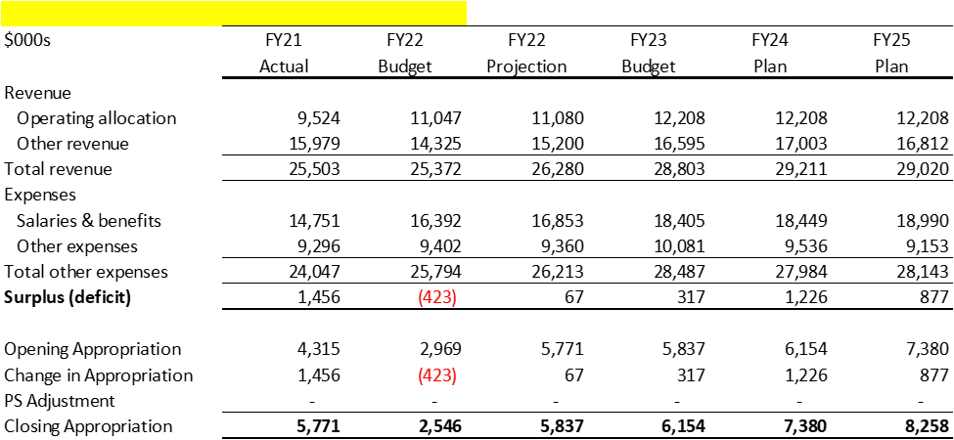

## Revenue

### Operating allocation

Where an envelope has significant change in the operating allocation, please describe the major changes impacting the allocation, e.g. enrolment, teaching, drivers, priority funding from UF or Budget Committee etc.

### All other revenue

Please describe other **major** sources of revenue (>$200K) outside of the operating allocation included in this budget submission.

## Staffing

### Academic positions

Please complete the table and outline hiring plans and justifications for any changes to Academic FTEs and if relevant, how they are linked to changes described in section 3.1 Objectives.

|  | Actual | | | Projected | | | |
| --- | --- | --- | --- | --- | --- | --- | --- |
| 2018/19 | 2019/20 | 2020/21 | 2021/22 | 2022/23 | 2023/24 | 2024/25 |
| Tenure track |  |  |  |  |  |  |  |
| Teaching track |  |  |  |  |  |  |  |
| CLA |  |  |  |  |  |  |  |
| CAWAR |  |  |  |  |  |  |  |
| **Total** |  |  |  |  |  |  |  |

### Staff Positions

Please complete the table with staff complement as of year-end for each year. Outline hiring plans and justifications for any changes to support staff FTEs and if relevant, how they are linked to changes described in section 5.1 Objectives.

|  | Actual | | | Projected | | | |
| --- | --- | --- | --- | --- | --- | --- | --- |
| 2018/19 | 2019/20 | 2020/21 | 2021/22 | 2022/23 | 2023/24 | 2024/25 |
| Support staff |  |  |  |  |  |  |  |
| Add Support staff - cost recovery |  |  |  |  |  |  |  |
| Support staff - spec funded 45 |  |  |  |  |  |  |  |
| Total Support Staff |  |  |  |  |  |  |  |
| Part-time/casual/student |  |  |  |  |  |  |  |

***Definitions***

***Support staff: S****taff paid from this envelope, not including those reported in the categories below.*

***Support staff-cost recovery:*** *Staff paid from this envelope but cost recovered either directly or indirectly. (eg. Faculty career office is funded by co-op fees and should be reported on this line)*

***Support staff - spec funded 45****: Staff paid on Fund 45*

***FTE*** *= Full time equivalent. Refers to the number of employees, prorated by either their regularly scheduled hours (eg. hired for 4 out of 5 days a week equals 0.8 FTE), or if a shared position, by the percentage paid by this envelope. Please note that the FTE data calculated by Hyperion which shows on the financial submission further prorates FTE by the number of hours actually worked in the year (i.e. takes into account time of year position was vacated or replaced and leaves of absence, etc.). The difference in the two numbers should give you a good idea of historical employment gapping.*

## Other expenses

Please describe any changes in other expenses or **major** expenses (>$200K).

## Significant cost pressures

### Name of cost pressure #1

Please describe cost pressure and any mitigation strategies, quantify if possible

### Name of cost pressure #2

Please describe cost pressure and any mitigation strategies, quantify if possible



## Summary of items in Budget

Use the table below to summarise **only items** **in the budget** in terms of significant new initiatives and cost pressures.

Sample table:

|  |  | |  | Impact - Favourable/(Unfavourable) | |
| --- | --- | --- | --- | --- | --- |
| Major Action | Fiscal Year | Likelihood? | | One-Time | Ongoing |
| New program | 22/23 | High | | (150,000) | 300,000 |
| External recovery | 23/24 | Medium | |  | 500,000 |
|  |  |  | |  |  |
|  |  |  | |  |  |
| Total |  |  | | (150,000) | 800,000 |

## Plans for use of appropriations

Describe how you will use any surplus appropriation balance. Where an envelope has existing structural deficits and/or accumulated debt please describe the plan to eradicate this along with the timeline and include the impact in the table above.

## Capacity Constraints and Capital Budget Plans

Click here to enter text.

# Major Opportunities and Key Risks to Your Operational Plan

List describe and if possible quantify

# Other Major Assumptions

Please detail any assumptions that differ from or are in addition to the budget guidelines and are not included elsewhere in this document.

# Narrative of Envelope Highlights

Please provide a paragraph of highlights which may be included in the consolidated budget document, **please write as if for an external reader (i.e. avoid the use of “we” and “our”) as this section is used in the published Consolidated Budget document** – maximum 300 words.

|  |
| --- |
| ***Details of key strategic initiatives and ties to Strategic Mandate Agreement***  *Paragraph 1* |
| ***Budget challenges***  *Paragraph 2* |
| ***Actions taken and planned additional actions***  *Paragraph 3* |

# Appendix A – Organizational Chart

Please append the most recent organizational chart

# Appendix B – Strategic Mandate Agreement Activities

Optional: Please provide further information or details on current and planned activities impacting specific SMA 3 performance metrics.

1. G6 leading research-intensive universities in Ontario are McMaster University, University of Ottawa, Queen’s University, University of Toronto, University of Waterloo, and University of Western Ontario.
2. U15 Group of Canadian Research Universities are University of Alberta, University of British Columbia, University of Calgary, Dalhousie University, Université Laval, University of Manitoba, McGill University, McMaster University, Université Montréal, University of Ottawa, Queen’s University, University of Saskatchewan, University of Toronto, University of Waterloo, and University of Western Ontario.