How to open Hyperion Forms using the Web Platform
- Open Hyperion by going to URL: https://hyperion.mcmaster.ca/workspace/  - Enter your MACID and Password | 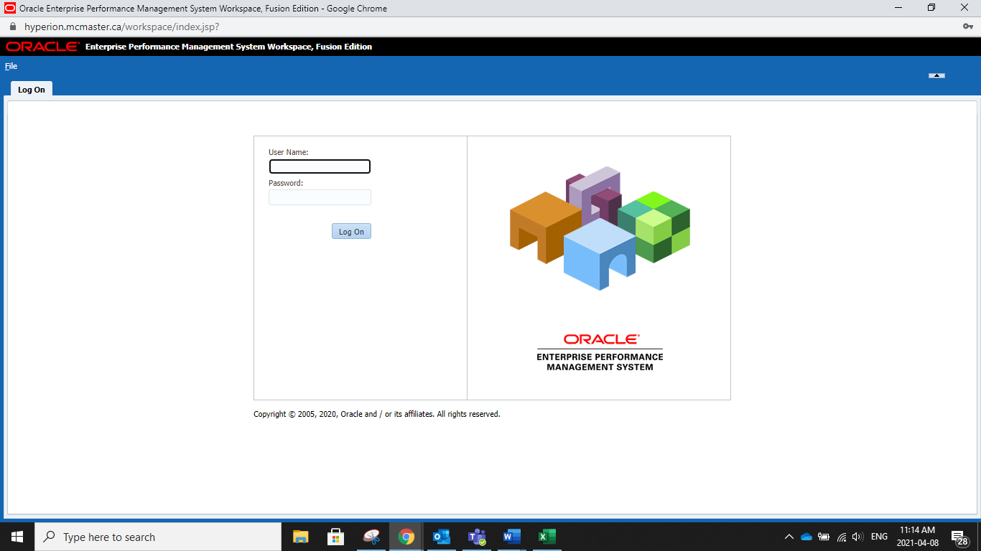
- The Hyperion system opens.  - Click on Explore | 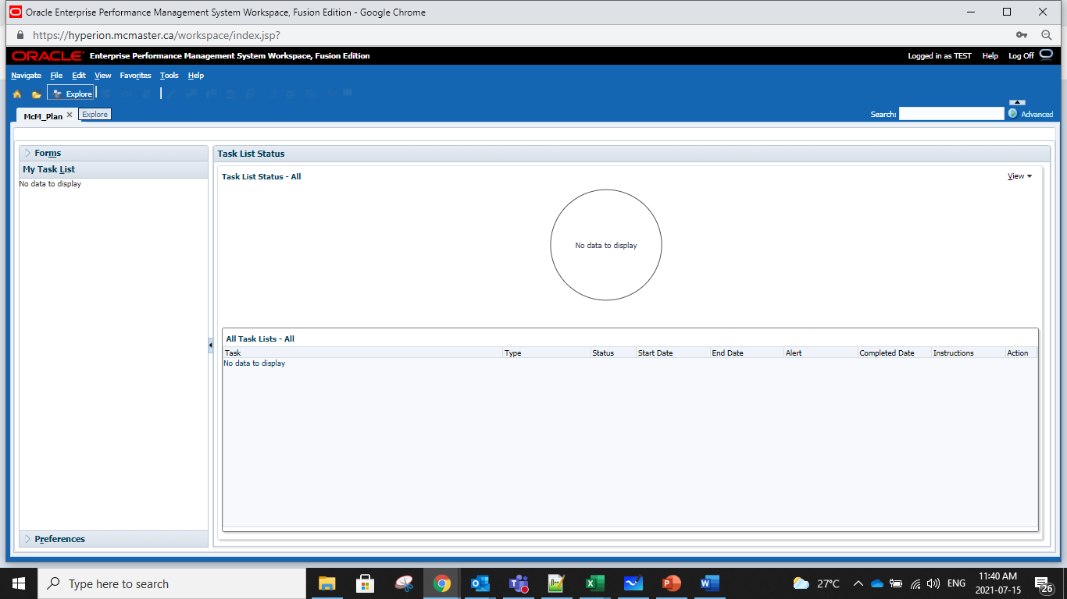
- Expand the Reports Folder by double clicking. | 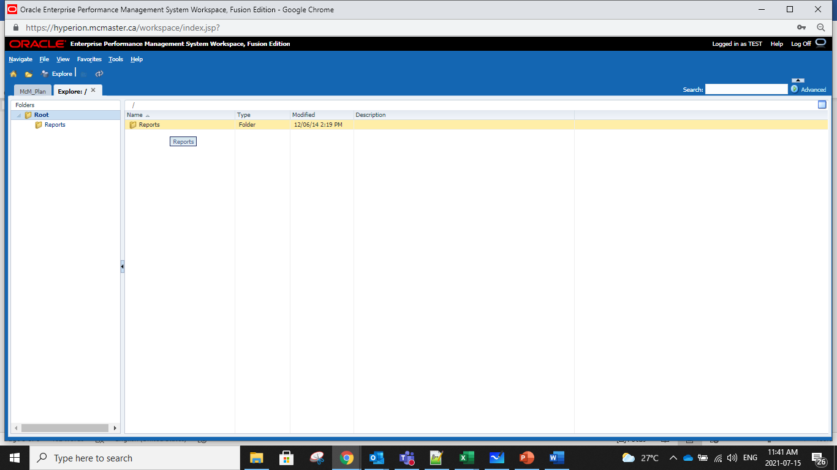
- Open the submission report by double clicking on the report you want to open | 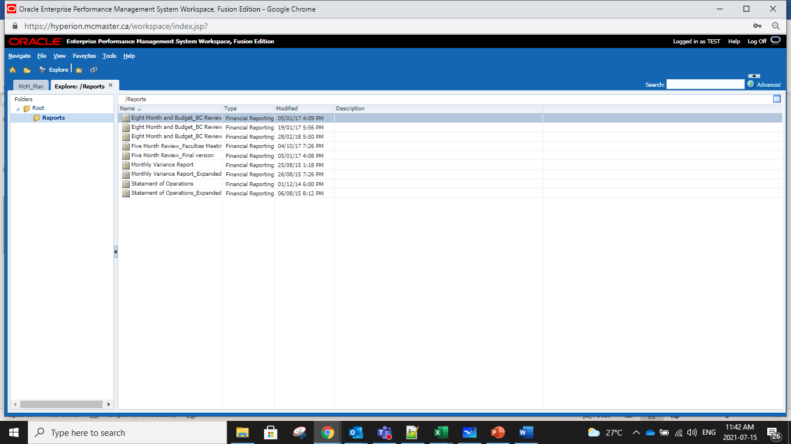
- Click the search to select the department or envelope | 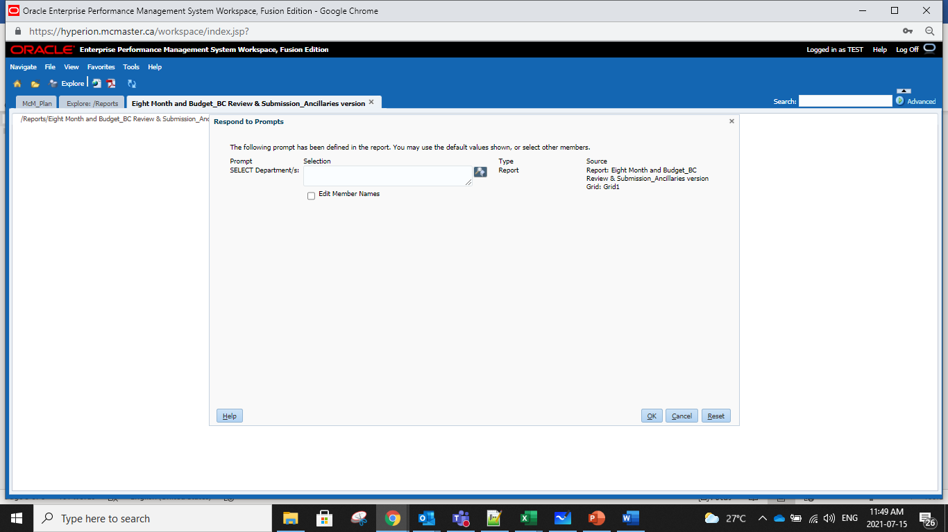
- Select the department or envelope and click the right arrow to move to selected pane | 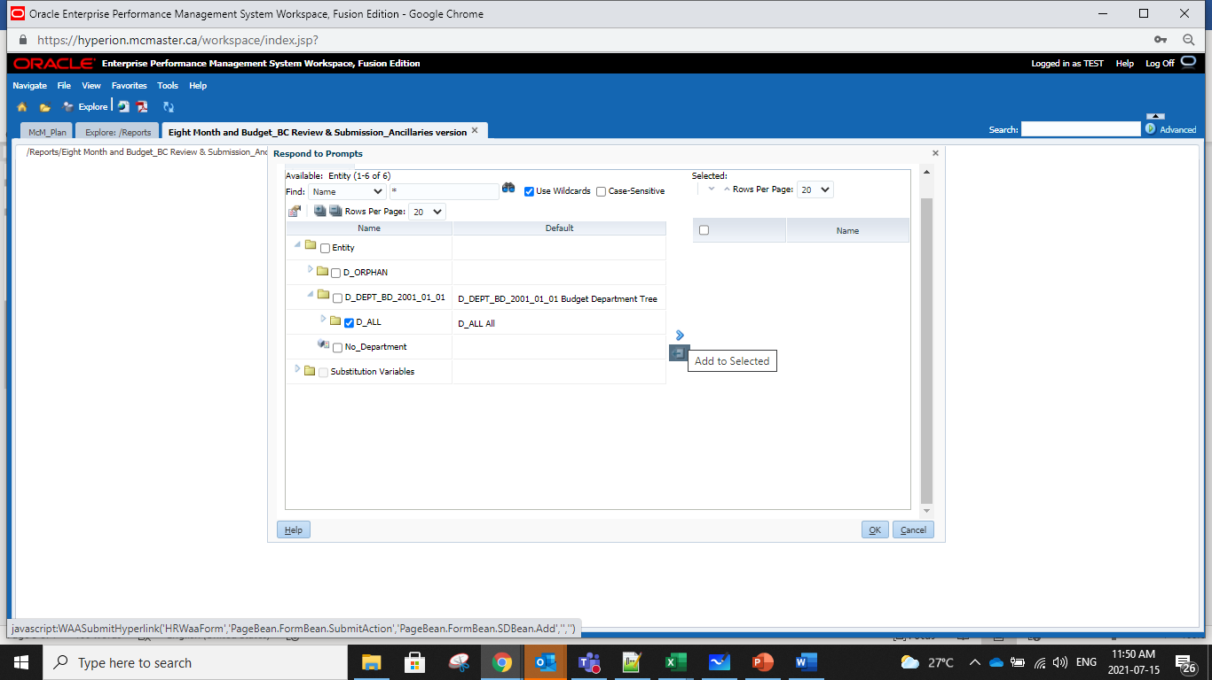
- Double Click the form to open in the LEFT PANE
- The department or envelope is now on the right side pane. Click OK | 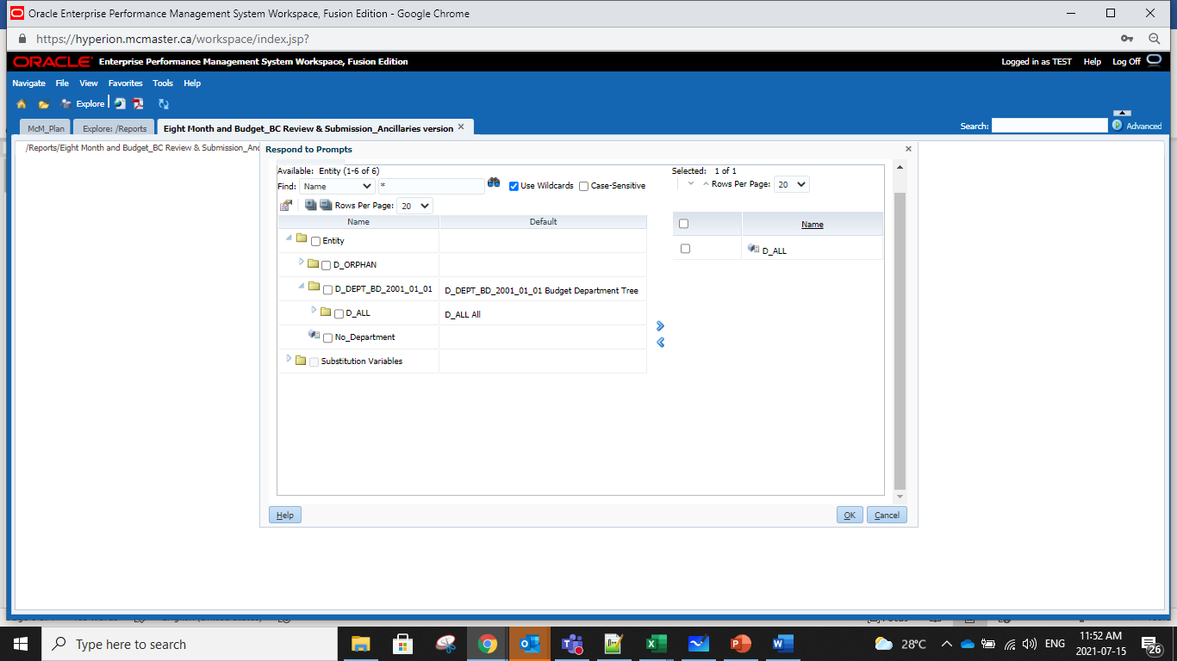
- The department or envelope are in the Selection box. Click OK | 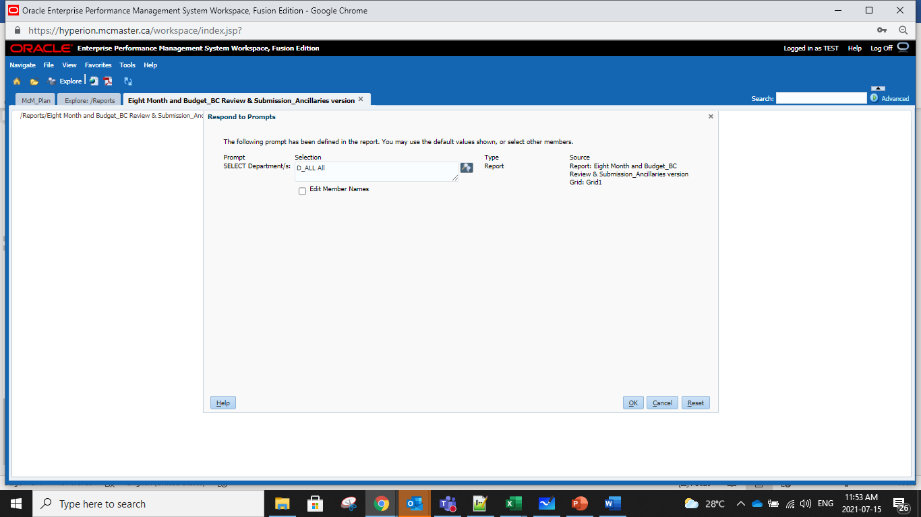
- Report is produced. Click the PDF button to export to PDF | 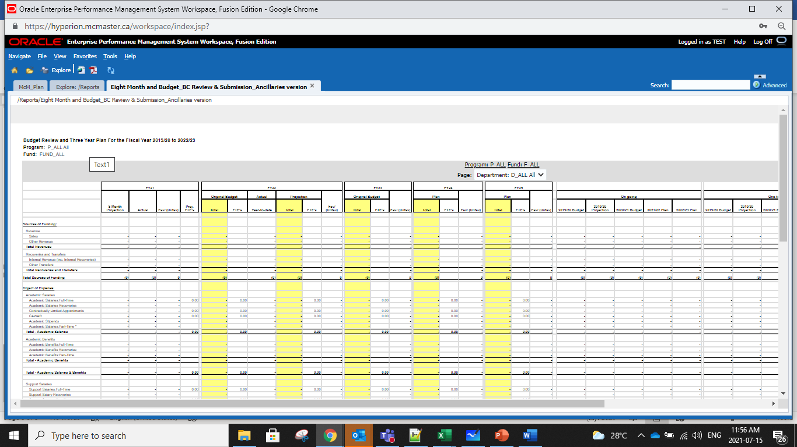
- PDF preview is shown. Click Download to download to your computer | 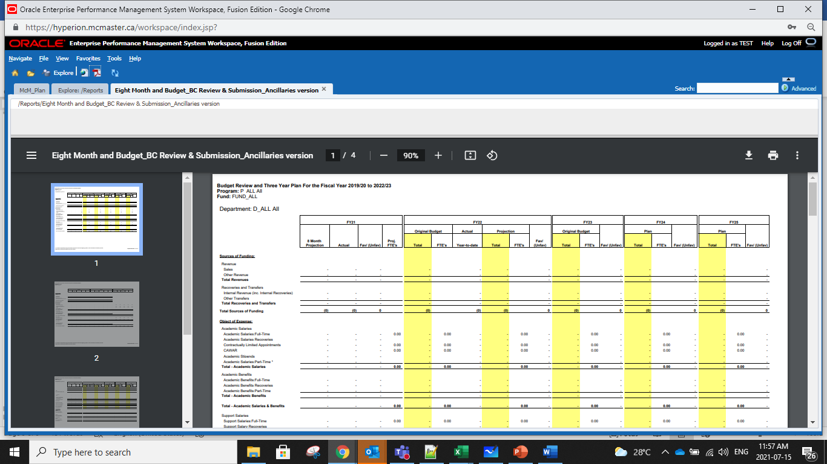
- Save on the folder of your choosing. Click SAVE | 